
Learning & Development Policy

Version Control and document governance
Document Title | Learning & Development Policy
Version | 2026/2
Level | All colleagues
Owner / Position | Alex Hammond – Learning & Development Manager
Reviewed by | Rosanna James – Head of People & Culture
Approved by | Governance Committee
Approval date | 18/6/2026
Review Period | 2 years
Date of next review | 18/6/2028

Version | Date | Summary of Changes
2026/1 | 18/06/26 | First version

Contents
1.0 Policy Statement 3
2.0 Definitions 3
3.0 Scope 3
4.0 Roles and responsibilities 4
5.0 Competence and Conduct 6
6.0 Professional Qualifications 6
7.0 Essential Skills 7
8.0 Membership of professional bodies 8
9.0 Conferences and Seminars 9
10.0 Performance Management Framework 9
11.0 Learning Records & Reporting 10
12.0 Agency workers 10

1.0 Policy Statement
1.1 At Broadacres, we recognise that the knowledge, skills and behaviours of our colleagues are fundamental to achieving our strategic objectives and delivering excellent services to our customers. We are committed to creating a positive learning culture where continuous learning and development is encouraged, supported and valued.
1.2 Learning and development activity will enable colleagues to perform effectively in their current roles, prepare them for future opportunities, and respond to organisational change. Broadacres will take a fair, inclusive and consistent approach to learning and development, ensuring opportunities are aligned to individual needs, team priorities and business objectives.
1.3 Responsibility for learning and development is shared. Broadacres will provide access to appropriate learning opportunities and resources, while colleagues are expected to take ownership of their own learning, actively engage in development activities and apply new knowledge and skills in the workplace.
1.4 All learning and development activity will support equality, diversity and inclusion, promote wellbeing, and comply with relevant legislation, regulation and internal policies. The Equality Impact Assessment of this policy is in Appendix A.
1.5 The terms of this policy may be varied from time-to-time at the Head of People & Culture’s discretion. This policy does not form part of any contract of employment.
1.6 Learning and Development activity will be evaluated to ensure that it meets organisational objectives, provides value for money and continuously improves.

2.0 Definitions
Essential Skills | Mandatory training for all colleagues that keep them, the business and our customers safe and compliant.
Role Specific Training | Training that is applicable to specific role(s) within the organisation that enable them to deliver their roles effectively.
Desirable Training | Training that is identified on an individual basis for continual personal development.
Learning Management System | I.T. system that manages the issuing of digital learning to colleagues, coordinating instructor led training sessions and maintaining accurate records of learning.

3.0 Scope
3.1 This policy applies to all Broadacres colleagues, including permanent, fixed -term and temporary employees, apprentices, and colleagues on secondment. Where appropriate, aspects of this policy may also apply to agency workers, contractors and volunteers undertaking work on behalf of Broadacres.
3.2 The policy covers all learning and development activity supported, funded or arranged by Broadacres, including mandatory training, role-specific development, professional qualifications, leadership and management development, and informal learning opportunities.
3.3 Learning and development will be delivered through a range of methods, including on-the-job learning, face-to-face training, digital learning, coaching, mentoring and externally provided programmes. This policy does not guarantee access to every learning opportunity; participation will be subject to organisational priorities, role requirements, performance needs, and available resources.

4.0 Roles and responsibilities
4.1 Broadacres Board is responsible for:
- Approving the Learning & Development policy.
- Ensuring that the policy supports the organisations strategic objectives and meets legal and regulatory requirements.
- Monitor the effectiveness of the policy, providing challenge and scrutiny where appropriate
4.2 Broadacres Executive Team is responsible for:
- Providing a framework for learning and development that supports organisational objectives and service delivery.
- Making appropriate learning and development opportunities available, subject to business priorities and resources.
- Identifying and monitoring mandatory training requirements.
- Promoting a fair, inclusive and positive learning culture.
4.3 The People team are responsible for:
- Designing, coordinating and delivering learning and development programmes aligned to organisational needs.
- Providing professional advice and guidance to managers and colleagues on learning and development.
- Working with operational managers and subject matter experts to ensure training meets current legislative and regulators requirements
- Maintaining records of learning activity and monitoring compliance with mandatory training requirements.
- Reviewing and updating learning and development provision to ensure it remains relevant, inclusive and effective.
- Evaluating the effectiveness of learning and development

4.4 Managers are responsible for:
- Identifying learning and development needs in line with role requirements and service objectives.
- Supporting colleagues to access agreed development opportunities.
- Ensuring colleagues complete essential skills training and all role relevant learning.
- Encouraging the application of learning in the workplace.
4.5 All colleagues are responsible for:
- Taking ownership of their own learning and development.
- Actively engaging in learning activities relevant to their role.
- Attending mandatory training and completing learning within required timescales.
- Applying learning to improve performance and service delivery.
- Keeping learning and CPD records up to date.

5.0 Competence and Conduct
5.1 This policy complies with the Regulator of Social Housing’s Competence and Conduct Standard, hereby referred to as ‘the standard’, ensuring colleagues have the skills, knowledge, experience and behaviours required to deliver professional, high-quality housing services in a competent manner.
5.2 The Broadacres Code of Conduct outlines the expected minimum standards of professional behaviour and conduct of all colleagues.
5.3 These expectations are communicated to all colleagues as part of the onboarding element of the recruitment process and through essential skills learning.
5.4 Colleagues competence and conduct is developed and managed through Broadacres Performance Management Framework described in section 9 of this policy.

6.0 Professional Qualifications
6.1 Where appropriate, professional qualifications that are deemed essential to establish the minimum level of competence required for each role have been identified and are clearly described in the relevant Job Description.
6.2 Professional qualifications deemed to be essential to comply with the mandatory qualification requirements of the standard are deemed as essential and clearly described in the relevant job description.
6.3 The Learning & Development Manager will assess the Broadacres organisational structure to identify the roles and individual colleagues who are in scope of the mandatory qualification requirement of the standard.
6.4 The Broadacres assessment of roles in scope of the mandatory qualification requirements of the standard is reviewed annually and approved by the Head of People and Culture. The assessment includes a gap analysis of any colleagues in roles where their current qualifications do not meet the requirements of the standard.
6.5 Where current colleagues do not meet the qualification requirements of the standard, an action plan will be approved and delivered to ensure compliance is achieved and maintained.
6.6 Evidence of qualifications held by colleagues will be collected as part of our recruitment process and maintained in line with personnel data and GDPR.
6.7 Where colleagues join the organisation or move internally into a role in scope of the mandatory qualification requirements and they aren’t already qualified to the required level or subject, they must agree to begin working towards an appropriate qualification. The appropriate qualification(s) will be those detailed in the Job Description.
In line with the requirements of the standard, colleagues will begin working towards the appropriate qualification after 6 months of commencing their new role, and in all cases within 12 months.
6.8 All colleagues at Broadacres have the opportunity to apply to be supported by the organisation to obtain a Professional Qualification that is relevant to their current or future role.
6.9 The application process is detailed in the Broadacres Professional Qualification Guidance document.
Applications will be reviewed against organisational priorities and available budget and resources.
If an application is declined, colleagues will have the right to appeal the decision in line with the Professional Qualification Guidance.
6.10 Where approved, colleagues will receive financial support to pay the fees, subject to the colleague agreeing to and signing the Learning & Development fees agreement.
Colleagues will be also supported with appropriate time to attend workshops, classes and/or learning events. There is an expectation that colleagues invest some of their own time to complete assignments and coursework.
6.11 On successful completion of qualifications colleagues will be required to submit copies of their certificate(s) that will be held and retained as part of their personnel and training record.
6.12 Where professional qualifications require re-assessment (e.g. Gas), and it is a requirement for the colleague to be able to carry out their role, Broadacres will arrange for the reassessment to be carried out in work time and pay the fees. In these circumstances Broadacres may waive the requirement to sign the Learning & Development fees arrangement.

7.0 Essential Skills
7.1 Broadacres has an approved suite of learning for all colleagues, our Essential Skills. This will develop the skills, knowledge and competence required to deliver high-quality housing services, to keep our colleagues and customers safe and the business compliant with legal and regulatory requirements.
7.2 The Head of People & Culture will approve the learning that is included in the Essentials Skills suite in conjunction with the Operational Leadership Team. This will included the frequency of periodic refresher training for each subject.
7.3 New colleagues will be automatically enrolled onto the relevant Essential Skills on joining the organisation. They will be expected to complete all learning during their first 6 months of employment (unless appointed through agency, see section 12) Successfully completing all Essential Skills Learning is a pre-requisite to colleagues successfully completing and graduating from their probation period.
7.4 Colleagues will be notified by email from the Learning Management System (Learning Zone) when Essential Skills learning requires a periodic refresher. Notifications will be sent 12 weeks prior to the expiry date (check settings).
7.5 All colleagues are responsible to ensure they complete periodic refresher training of Essential Skills courses within the designated timescales. Any issues that may prevent timely completion should be discussed with the immediate line manager in the first instance and escalated to the People team if cannot be resolved.
7.6 Failure to complete mandatory learning within the required timescale may be managed in line with Broadacres Performance Management Framework.

8.0 Membership of professional bodies
8.1 Broadacres will support colleagues to maintain membership to professional bodies relevant to their role where it supports Continuous Professional Development.
8.2 The application process is detailed in the Professional Membership colleague guidance and application document.
8.3 Where approved, colleagues will receive financial support to pay membership fees and time to attend CPD events where appropriate. There is an expectation that colleagues also complete some CPD activities in their own time.
8.4 Colleagues are responsible for logging their own CPD activities in the Learning Zone.
8.5 To maintain membership support colleagues must be able to evidence the value they are receiving from accessing the benefits of their membership for themselves, the team and the organisation. They will be asked to submit a short statement at the end of each membership period before membership is renewed.

9.0 Conferences and Seminars
9.1 Colleagues can apply to attend conferences and seminars that are relevant to their role where there is a clear business benefit to attending.
9.2 Applications must be made using the Conference & Seminar application form which must be approved by an immediate line manager, and Head of Service or above.
9.3 Final approval decisions will be made by the Head of People & Culture based on relevance to business priorities and available budget and resources.
9.4 Following attendance to a conference or seminar colleagues will be required to complete a short evaluation detailing the benefits gained. This will help inform future decisions about colleagues attending events.

10.0 Performance Management Framework
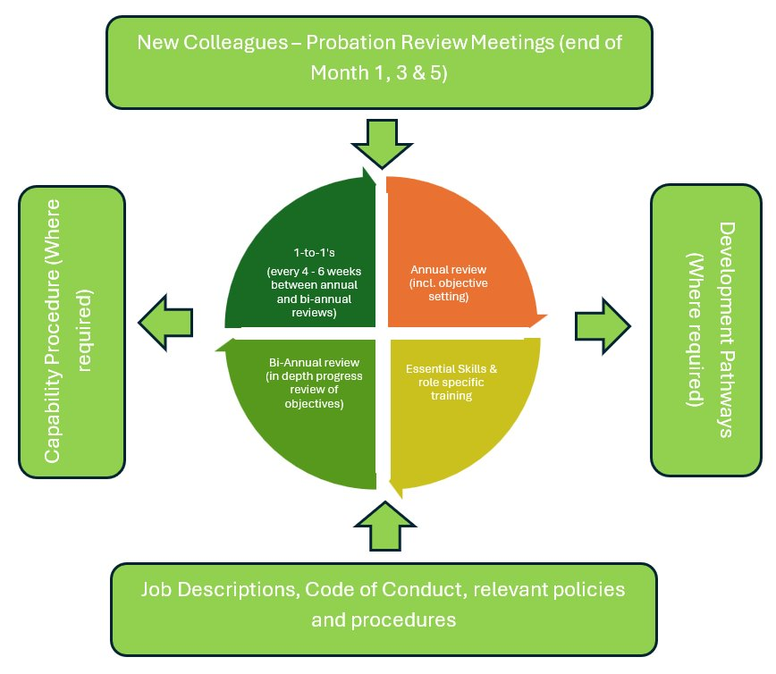
10.1 The Broadacres Performance Management Framework (PMF) details the approach that the organisation takes to supporting the development of competence and conduct throughout the various stages of the colleague lifecycle.

10.2 The PMF ensures we are equipping colleagues with the right development and providing the ongoing direction and support they need to succeed in their role, through our probationary process, essential skills development, annual reviews and regular 1-to-1’s .
10.3 The People team and line managers will initiate relevant development pathways at appropriate points in a colleague’s career. These will include, but are not limited to:
- The Onboarding & Induction pathway for new colleagues
- Appropriate specific pathways for colleagues who change role
- Management Development pathway
- Professional Qualification pathway
10.4 All colleagues are required to engage with the activities described in the PMF.
10.5 Line Managers, in conjunction with the People team, will follow the Capability procedure in the event that competence and/or conduct falls below expected standards.

11.0 Learning Records & Reporting
11.1 The People team are responsible for ensuring the accurate maintenance of colleague learning records within the Learning Management System following the completion of training. This will include all learning coordinated by Broadacres.
11.2 Completion rates of Essential Skills will be reported to OLT on a monthly basis based on colleagues learning records held within the Learning Management System.
11.3 A quarterly Learning & Development report will be presented to OLT detailing all learning activity and compliance with the requirements of the competence and conduct standard.

12.0 Agency workers
12.1 Specific requirements for professional qualifications deemed essential to roles will be provided to the agency as part of the procurement process. The agency will be expected to only provide candidates that meet minimum qualification requirements.
12.2 Evidence of a candidate’s qualifications and/or training will be obtained prior to the agency worker commencing work.
12.3 Agency specific Essential Skills courses will be allocated to the worker, as described in the approved suite of Essential Skills learning that is maintained in the Learning Management System.
12.4 The hiring line manager is responsible for communicating Essential Skills Learning expectations, courses should be completed within 4 weeks (or earlier depending upon length of contract).

