Chris Hyde & Andy Powell
Broadacres Housing Association
Damp, mould and condensation strategy 2025-2028
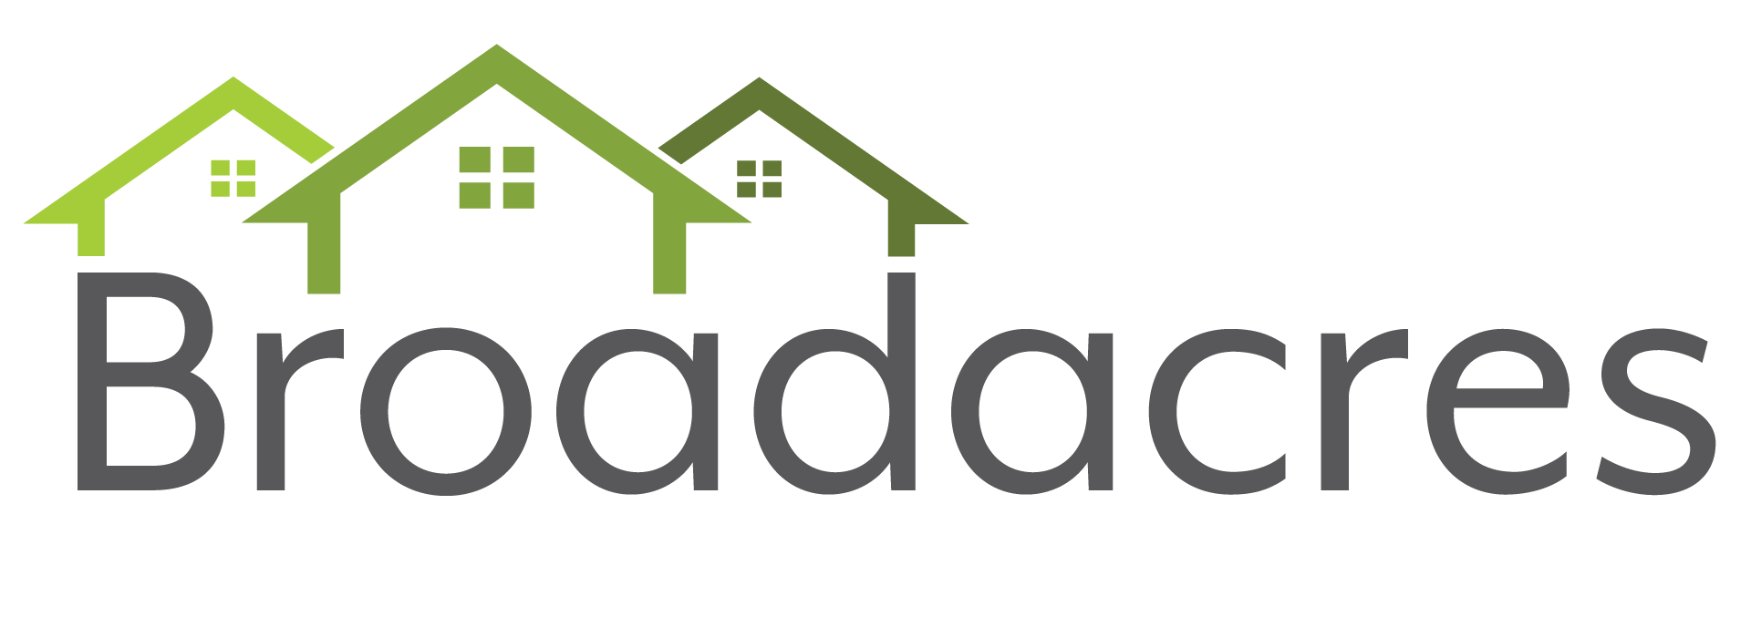

Damp Mould and Condensation Strategy 2025-2028

Introduction
This is the second Damp, Mould and Condensation Strategy, and it brings our plans for the effective management of Damp, Mould and Condensation (D&M) up to date. The strategy does not stand in isolation and is intended to support the delivery of the Asset Management, Customer and Sustainability Strategies.

This version is a comprehensive rewrite of the 2022 strategy. The previous strategy reflects the timing of its production in that there was a requirement to respond directly to the challenges facing the social housing sector following the Rochdale tragedy in 2020. It was structured around an organisational response to the Housing Ombudsman’s October 2021 Spotlight Report , and the four themes contained within that report; from the reactive to the proactive, from inferring blame to taking responsibility, from disrepair claims to resolution and from a complaint to a learning culture, were carried through as the strategic aims within the strategy and have proved an effective springboard to developing our approach to D&M.

We are now within a more “steady state” period where the management of D&M is encapsulated within policy and practice. Since the development of the previous strategy there has been significant developments in our practice in managing D&M. This has included investment in training, ICT, communication with customers and investment directly into the fabric of homes.

This second strategy aims to take the organisational vison for the management of D&M through this steady state, reflecting the changes in the legislative and regulatory landscapes, and anticipating the introduction of the new Broadacres Responsive Repairs Policy when Awaab’s Law is enacted in October 2025.

Firstly, in setting the scene for the strategy it is important to understand the nature of the hazard posed by D&M and the occurrence of D&M within Broadacres homes.

Part 1: The Nature of Damp, Mould and Condensation and its Occurrence in Broadacres Homes

Damp and Mould: The Silent Hazard in Homes
D&M is a significant hazard. The NHS spends an estimated £1.4 billion annually on treating illnesses associated with damp and cold housing and recognises that mould causes significant health issues, as well as the misery it causes for the people living in the homes affected. Therefore, the impact and prevalence of D&M justifies a strategic approach.

It is usually easy to spot when a home has a mould problem, although some types of mould are not visible. Typically, it appears as a dark stain or black growth around windowsills, walls and ceilings. Mould is not only unsightly, for some people it is extremely dangerous and can be deadly as it was in the tragic case of Awaab Ishak. Children, people with allergies and older people are particularly susceptible. Once mould spores are airborne, they can be inhaled, causing respiratory infections and long-term illnesses. A House of Commons Research Briefing: Health inequalities cold or damp homes highlighted that problems go beyond physical illness. Cold or damp conditions can have a significant impact on mental health, with depression and anxiety more common with people living in these conditions.

Regarding prevalence, the English Housing Survey 2023 to 2024 reported that 5% of dwellings in England had a problem with damp, a rate higher than that in any of the last 5 years (3-4% average). Damp has increased across all tenures since 2019 and was more prevalent in the private rented sector (9%), compared to the social rented sector (7%) and owner-occupied sector (4%). Serious condensation was more prevalent in homes (3%) than rising damp (2%) and penetrating damp (2%). Within the social rented sector, local authority dwellings were more likely to have serious condensation (7%) than housing association dwellings (4%).

In developing a strategy for the management of D&M, it is important to understand the basis of D&M and its common causes.

What is Mould? Mould is a microscopic fungus resulting from two ingredients: damp and microbes. There are potentially hundreds of species of mould within the air of homes, many entering from outside, but often produced indoors. For example, mould fungus breaks down dead organic material found in carpets and even wallpaper.

Mould can also build up in spaces where air does not circulate very well, for example behind wardrobes or in cupboards. Therefore, even in the cleanest home the potential for mould is always there once excess moisture becomes a factor. When the mould grows it emits more spores into indoor air. Without proper intervention the problem almost always gets worse.

Why do Homes become Damp? Damp in a home can be caused by several factors. Some of these can be structural, for example leaking pipes or rain seeping through a defective roof. Rising damp can also be a problem where the damp proof course has failed or has been breached, for example where the ground level of a home has been raised above the level of the damp proof course by poor maintenance or other works.

Unfortunately, dampness can be caused by everyday home activities such as bathing and showering, cooking or drying clothes on a rack. Even occupants sleeping in a bedroom exude moisture. Water vapour from these everyday activities can collect on cold surfaces such as walls, windows and sills. This is known as condensation.

Condensation forms on walls and other surfaces more quickly when the home is cold. Using less heating in the winter can lead to more problems with long term damp conditions. Excessive indoor moisture makes a home feel colder. In periods of higher utility costs, homes not being adequately heated raises the risks of both damp and mould.

The Operating Context
This strategy has been developed within a changing and continuingly challenging operating context. From the Grenfell tragedy onwards the reputation of the social housing sector has been under intense scrutiny. The combination of repairs scandals, damp and mould and the harm this has caused to social housing tenants, has eroded trust between the sector with customers, the Government, the Regulator and the wider community.

The changes in the operating environment summarised above have required a significantly different approach in assessing and delivering repairs and maintenance and the management of hazards, particularly D&M. Notably, the enactment of Clause 42 of the Social Housing (Regulation) Act 2023 has changed the regulatory environment and contractual relationship between social housing providers and their customers. This effectively inserts into social housing tenancy agreements a term that will require landlords to comply with new requirements with Awaab’s Law which is expected in October 2025. This means all registered providers of social housing will have to meet these requirements and, if they fail to do so, customers will be able to hold their landlords to account by taking legal action through the courts for a breach of contract.

(HHSRS) is part of the Decent Homes Standard, which registered providers of social housing must comply with. Under the Decent Homes Standard, a residential property should be completely free from category 1 hazards identified within the HHSRS to be considered decent. As part of the response to the challenges above the previous and current Governments have promoted the extension of the use of the HHSRS. Throughout the sector, responsive repairs policies have historically been structured by providers to treat category 1 hazards as emergencies or urgent repairs, but typically this has often been without directly referencing the HHSRS. The step change for the sector is that going forward hazards such as D&M will not only need to be prioritised by the hazard posed by the repair issue itself but will also need to acknowledge the vulnerability of the individual customers within the household to the potential hazard and the impact it has upon them.

In April 2024, the Board agreed to the principle of a reviewed Responsive Repairs Policy which amalgamates the Responsive Repairs Policy with our approach to the management of HHSRS hazards (including D&M). The policy has been designed to respond to the changes expected within Awaab’s Law when it is enacted and will be reviewed again once the detailed requirements are confirmed.

Since the introduction of the 2022 strategy our focus has been to embed a zero-tolerance approach to D&M and continue to actively seek cases of damp and mould. For example, all customers’ homes where we receive reports of damp and mould issues are inspected by a property surveyor and appropriate actions taken and works delivered.

Extensive damp and mould surveys continue to be conducted as part of every stock condition survey and following any report of damp or mould from a customer. The aim to ensure a consistent, methodical approach. All in-house decorators have been trained in the application of mould treatment products.

Since the introduction of Salesforce, we have introduced a process so that a mould wash is booked in with the customer at the first point of contact following a report via the contact centre, operative referral. If the triage identifies a higher category hazard, a property surveyor inspection will be scheduled within the statutory timescales. Damp and mould cases are managed by property surveyors and only closed following remedial works and customer follow up, ensuring work has been completed and reducing follow up calls.

The above approach has resulted in a positive response from customers. Within the feedback from the 2024 Tenant Satisfaction Measures, 89% of customers considered their home well maintained (85% in 2023) and 92% consider that they have a safe home (89% in 2023). Transaction satisfaction captured through the “Rant & Rave” survey software shows that customers consistently rate satisfaction with the repairs service above 4.5 out of 5. Following the inspection of Broadacres by the Regulator for Social Housing in the summer of 2024 the subsequent report concluded that “Broadacres provided evidence-based assurance that it has appropriate systems in place to ensure the health and safety of its tenants in their homes and associated communal areas”. Also, that “Broadacres demonstrated that it provides an effective, efficient and timely repairs service to tenants. It has made proactive, tenant focused improvements to the repairs service to improve outcomes for tenants.”

Broadacres has received relatively low levels of disrepair claims. These claims are often based on the management of D&M issues. Between January 2024 and January 2025 eight claims were received. In the previous year 2023/2024 nine claims were received, of which three were settled.

Damp &Mould within Broadacres Homes
An objective set within the original D&M Strategy is that Broadacres take a data driven approach towards the management of D&M.

As a result, data has been captured within the intervening period which is enabling the analysis of the prevalence of D&M in Broadacres homes. Identifying, for example, the location, age, property type, household composition, repairs and investment history helping build a strategic profile of the impact of D&M and shaping the response.

The collection of this data and its analysis is an iterative process. The journey began with tracking the demand from customers reporting issues of D&M in their homes.

The next iteration has been an analysis to understand which homes have been most prevalent to reports of damp and mould. This has been followed by gaining an understanding of the attributes of these homes; their location, age, type/size, construction, condition, heating source and SAP rating. Next steps will be to map out the investment made in homes with the highest instance of reported D&M and the extent that investment made, intending to improve their thermal and energy efficiency, is impacting upon the incidence of D&M reporting.

The above analysis is building our understanding of how the attributes of individual homes is impacting upon the risk of D&M becoming a hazard (see below). To fully understand the inherent risk posed by D&M to individual homes involves not only understanding the risks posed by the property attributes, but also the variables and other factors impacting upon the risk of D&M in the use and operation of individual homes. This includes the vulnerability of the individual customers within the household to the potential hazard and the impact upon them.

The incidence of reported Damp &Mould within Broadacres Homes: In December 2024 Salesforce case management went live for D&M. This provides performance dashboards and the capability to drill down to each individual case which provides visibility. Not only of the overall occurrence of reported D&M within Broadacres homes but also reports on the milestones achieved in management of individual cases, the caseload as a whole and the number and details of hazards identified in individual homes.

In summary, analysis of the caseload shows that during December 2024, January 2025 and February 2025 that an average of 74 (1.07% of the stock) Broadacres homes had opened a D&M case each month.

In March 2025, 87 homes had open D&M cases (1.2% of Broadacres stock). Figure 1 benchmarks caseload with a range of other regional providers.

Figure 1: D&M caseload as % of stock

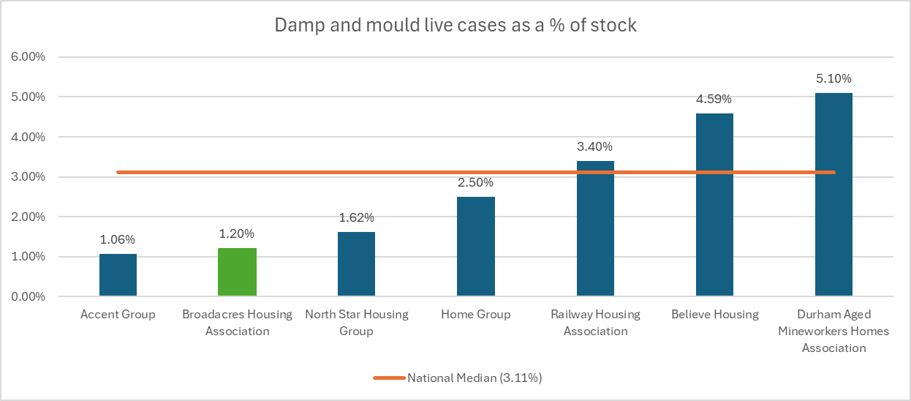

Housemark benchmarking reports that the national median for D&M live cases is 3.11% of stock with a live D&M case. At 1.20% of stock, this places Broadacres within quartile 1 of Housemark benchmarks for this measure at March 2025.

The above data provides a snapshot of cases. Table 1 includes a medium-term analysis of D&M caseload April 2024 to December 2024.

Table 1: Broadacres D&M Caseload April 2024 to December 2024

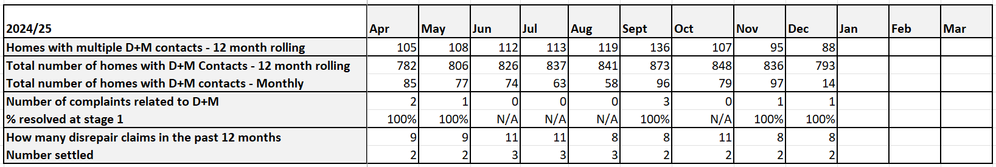

As referenced above, the Salesforce case management software went live in November 2024, and prior to this data was extracted from the QL Housing Management System. The data in table 1 demonstrates that both number of homes with monthly contacts and over a rolling 12-month period follow a seasonal pattern, i.e. reports of D&M increase during the colder months when the risk is highest.

Table 2 is the same analysis as Table 1 but for the period March 2023 to February 2024. This brings into focus the seasonal nature of reporting, with significant spikes in reports over the winter of 2023/2024. This in turn impacted and increased the number of homes with multiple D&M contacts during 2024 and in the 12-month rolling figure.

Table 3 is again the same analysis taken for the period September 2022 to March 2023. The analysis shows extremely high numbers of reports of D&M during November/December 2022 and January 2023. This period covered the publication of the original strategy, Broadacres change of approach in the management of D&M and the high national profile of the hazard posed by D&M. Demand was intensified by December 2022 and January 2023 being particularly cold and wet.

The Asset Management Performance Report to the Group Asset & Development Committee on 17 April 2023 highlighted the increase in customer contacts reporting a D&M issue:

- In December 2021, 47 customers contacted us with D&M issues (150 in December 2022).
- In January 2022, 72 customers contacted us with D&M issues (193 In January 2023).
- In February 2022, 42 customers contacted us with D&M issues (97 in February 2023).
- In March 2022 , 35 customers contacted us with D&M issues (78 in March 2023).

These were significant increases in reporting and even considering the harsher conditions during the winter of 2022/2023 suggested that customers had become much more aware of the hazard posted by D&M and Broadacres responsibility for responding to D&M as a hazard. The reasons for this may have been the increased awareness of the risk posed by D&M following the Rochdale tragedy and by the targeted public information campaign by the Government highlighting the risk and the responsibilities of social housing providers (see figure 2).

Coupled to increased awareness, wholesale energy prices increased rapidly from the second half of 2021 and in much of 2022. Although the number of D&M contacts have not repeated the peak of the winter of 2022/2023, monthly reports of D&M have continued to be on average double those experienced in 2021.

Figure 2: National Government Campaign March 2023

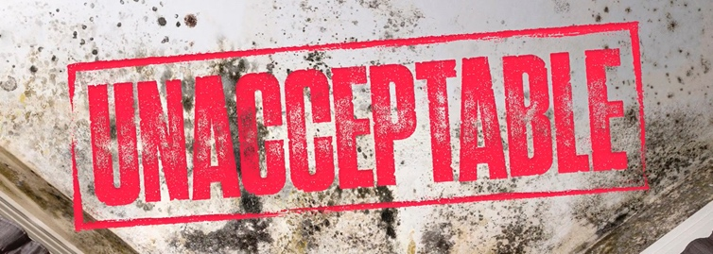

Table 2: Broadacres D&M Caseload March 2023 to February 2024

Trend | Mar | Apr | May | Jun | Jul | Aug | Sept | Oct | Nov | Dec | Jan | Feb
Homes with multiple D+M contacts - 12 month rolling | 79 | 84 | 83 | 86 | 89 | 87 | 90 | 98 | 89 | 88 | 86 | 98
Total number of homes with D+M Contacts - 12 month rolling | 693 | 705 | 710 | 711 | 722 | 741 | 770 | 810 | 803 | 775 | 746 | 749
Total number of homes with D+M contacts - Monthly | 88 | 49 | 43 | 36 | 51 | 42 | 71 | 118 | 123 | 102 | 153 | 105
Number of complaints related to D+M | 2 | 1 | 0 | 3 | 1 | 3 | 0 | 5 | 2 | 1 | 6 | 4
% resolved at stage 1 | 100% | 100% | NA | 0.66 | 100% | 0% | NA | 80% | 100% | 100% | 100% | 100%
How many disrepair claims in the past 12 months | 9 | 10 | 10 | 10 | 10 | 11 | 10 | 13 | 14 | 14 | 12 | 12
Number successful | 1 | 2 | 2 | 2 | 2 | 2 | 2 | 2 | 2 | 2 | 1 | 0

Table 3: Broadacres D&M Caseload September 2022 to March 2023

2022/23 | Sept | Oct | Nov | Dec | Jan | Feb | Mar (up to 24th)
Homes with multiple D+M contacts - 12 month rolling | 32 | 37 | 44 | 46 | 63 | 73 | 78
Total number of homes with D+M Contacts - 12 month rolling | 382 | 393 | 465 | 504 | 645 | 670 | 693
Total number of homes with D+M contacts - Monthly | 34 | 56 | 144 | 150 | 192 | 97 | 78
Number of complaints related to D+M | 1 | 0 | 0 | 0 | 1 | 3 | 2
% resolved at stage 1 | 100% | NA | NA | NA | 100% | 100% | 100%
How many disrepair claims in the past 12 months | 4 | 5 | 4 | 4 | 5 | 8 | 9
number successful | 1 | 1 | 1 | 1 | 1 | 1 | 1

Property Type, Location, SAP Rating and Household Composition
The historical data above indicates that since 2021 there has been a significant change in customer behaviour with a significant increase in the reporting of D&M. To obtain a fuller picture of the incidence of D&M within Broadacres homes, analysis has also been carried out to identify the location and attributes of homes where reports and works to manage D&M have been most frequent during 2023/2024 and 2024/2025.

In undertaking the analysis there are three primary data sources:

- D&M customer contacts (pre-Salesforce go live 25 November 2025)
- Completed mould treatment.
- More substantial completed works where D&M has been identified.

Considering the cause and sources of D&M, two further drill downs were taken, the SAP rating of all the homes identified within the four postcode areas and the average number of occupants recorded within our database, although occupation data is notoriously unreliable.

The analysis identified four postcode districts where we have spent significantly more money and have received a higher proportion of D&M contacts than is representative. These are:

- DL6 (Northallerton East / Ingleby Cross): 22% of the contacts / 20% of BHA stock / 27% of the mould treatment spend / 27% of substantial D&M works
- TS9 (Stokesley/ Great Ayton): 22% of the contacts / 12% of BHA stock / 15% of the mould treatment spend / 17% of substantial D&M works.
- YO7 (Thirsk / Dalton / Topcliffe):14% of the contacts / 15% of BHA stock / 20% of the mould treatment spend / 20% of substantial D&M works
- YO61 (Easingwold / Huby / Brandsby):11% of the contacts / 9% of BHA stock / 15% of the mould treatment spend / 20% of substantial D&M works.

Tables 4 to 7, summarise the results for the four areas identified.

With property age and property type factored into the analysis, we have drilled down to each of the four locations to create a street-by-street view of the data.

Table 4: DL6 Northallerton East: Damp and Mould Orders completed 2023-2024 and 2024-2025

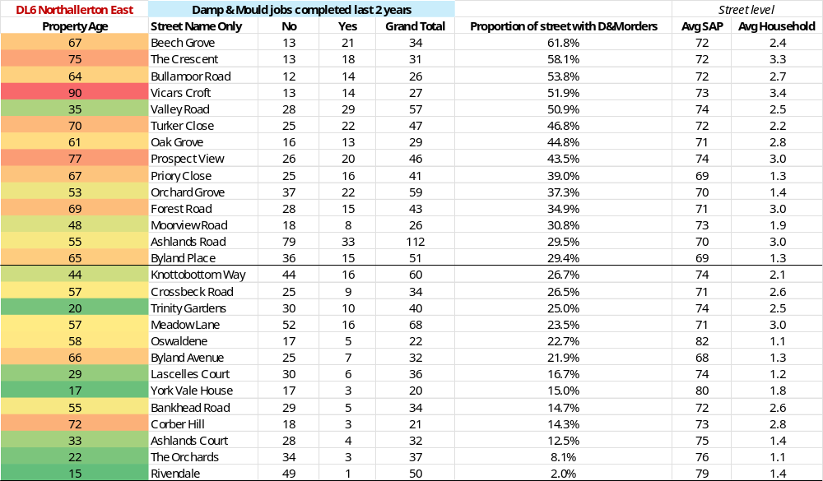

Table 5: YO7 Thirsk: Damp and Mould Orders completed 2023-2024 and 2024-2025

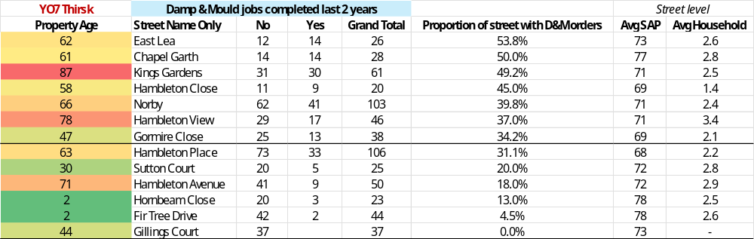

Table 6: TS9 Stokesley: Damp and Mould Orders completed 2023-2024 and 2024-2025.

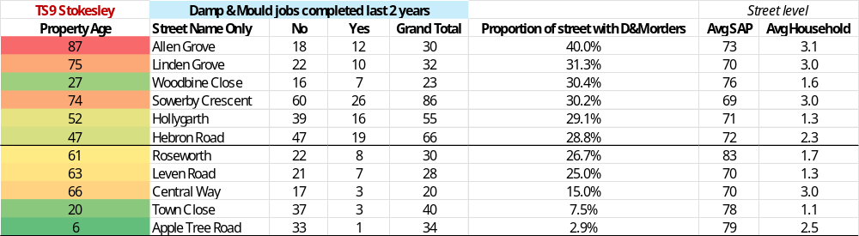

Table 7: YO61 Easingwold: Damp and Mould Orders completed 2023-2024 and 2024-2025

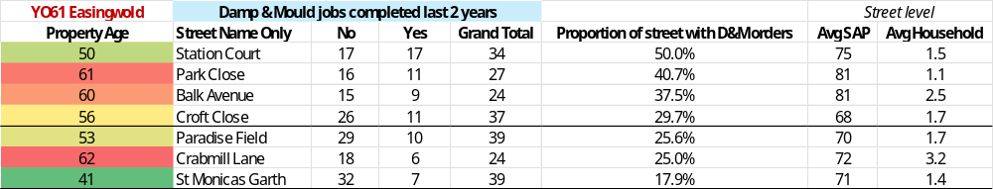

Conclusions
As a group, the four locations represent 56% of the BHA stock, but account for 84% of the substantial D&M spend and 77% of the specific mould treatment during 2023/2024 and 2024/2025.

Broadening the analysis to property age, there are additional insights from these locations.

The average age of homes in the BHA homes is 40 years. The homes in the above four postcode districts are on average 52 years old, compared with those in the remaining stock where the average age is 26 years. It is a similar picture with the bungalows, but not as pronounced a difference. The bungalows in the above four districts are on average 55 years old, compared with 50 years across the remaining locations. But 64% of all bungalows in the BHA homes are within these four areas.

Houses and bungalows generated the highest demand for D&M interventions. The exception is at Station Court in Easingwold which are traditionally built flats.

Only three of the streets identified at all four locations have a SAP below 69 (EPC C), the UK government target for social housing providers to attain by 2030 for ‘fuel poor’ households. They are Byland Avenue in Northallerton, Hambleton Place in Thirsk and Croft Close in Easingwold. None of these streets were ranked amongst the highest generators of D&M orders in their locality.

Neither did the streets generating the highest number of orders have significantly high occupation numbers. Although caution needs to be given to occupation data and that 64% of Broadacres bungalows are located within the four areas.

In conclusion, there would seem to be a correlation between age of the home and property type (house/bungalow), geographical location and the likelihood of a customer reporting D&M or Broadacres undertaking works as a result over the two-year period analysed.

Surprisingly, there is no positive correlation between low SAP score or heating type (streets with higher reported D&M were almost all EPC C or better and heated by gas).

It is also the case that average household size of homes within streets with the highest proportion of D&M orders is less than three persons.

Therefore, regarding property attributes, there is no clear determinant as to cause and effect. The data analysis therefore points to the importance of both the individual home and customer response in dealing with maintenance and/or utilisation issues as they are reported, rather than more “strategic” stock condition issues. This is not meant to imply that active strategic management and investment in homes which underperform regarding their energy efficiency will not reduce the risk of D&M.

Effective and timely response, along with education and information for both customers and colleagues, will be the primary defence to D&M and central to the strategic response.

Part 2: A Strategic Response to Damp, Mould and Condensation

The principles underpinning the effective management of D&M can be applied to the effective management of any hazard arising in customers’ homes, and more generally in the delivery of an excellent customer experience. That these principles are drilled into the organisational response make the management of D&M as routine as the management of any potential category 1 hazard such as the loss of electricity, heating or water.

In summary, the intention is that the cumulative effect of the five objectives laid out within this strategy is to build trust and provide assurance with customers, colleagues, internal/external governance structures and external stakeholders.

The objectives for the effective management of D&M are:

- Offering accessible services to customers which encourages and supports them to report issues.
- A timely response based on the severity of the hazard to the individual customer.
- An accurate diagnosis of the cause, effective treatment plans and aftercare.
- Developing our approach to the prevention of D&M.
- Effective governance, performance/risk management and strategic review.

Objective 1: Offering accessible services to customers which encourages and supports them to report issues
Registered providers must enable repairs and maintenance issues to be reported easily. If a customer does not report D&M or any hazard in their home this does not negate our responsibilities for keeping customers safe. The regulatory expectation is that we “know our silence” i.e. that we are active in contacting customers to ensure their homes are safe, they are using and living sustainably and that they are safeguarded. Over recent years, Broadacres has undertaken a “know our silence” programme, focusing on homes where there has not been contact or access for an 18-month period. This has focused on the risk of homes without the requirement for annual gas or Air Source Heat Pump servicing. The programme has identified homes and conditions which posed a hazard to customers.

Broadacres is a customer experience focused organisation and as such recognises that how me make a customer feel when they interact with us is as important as effective, timely and reliable service delivery.

Therefore, we will operate to the following principles:
- Ensure that we keep an appropriate range of channels open to customers that makes reporting easy with a single contact.
- Reassure customers when reporting a D&M issue that it is our issue to progress and not their problem or fault.
- Provide accessible information in order that customers feel fully informed as to the response they should receive.
- That our systems enable colleagues to effectively field contacts from customers and efficiently turn these into actions.
- Feeding back to customers demonstrating that if they report a D&M issue we will respond effectively.
- Ensure awareness and support colleagues to identify and report D&M utilising the opportunity during every conversation and visit.

Objective 2: A timely response based on the severity of the hazard to the individual customer
As identified within Part 1, the “step change” and challenge for the social housing sector is that going forward hazards such as D&M will not only need to be prioritised by the hazard posed by the repair issue but that it will also need to acknowledge the vulnerability of the individual customers within the household to the potential hazard and the impact it has upon them.

This requires that not only do the scripts, training and online templates available when customers report D&M effectively identify the severity of the D&M hazard, it does so within the information available regarding a customer’s or their household’s vulnerability. The priority and the nature of the response then reflects this. We will therefore adhere to the following principles:

- Scripts, training and online templates effectively identify nature and severity of the D&M.
- That the above also identify vulnerabilities within a customer’s household and the impact of D&M upon them.
- That the pace of the response is based upon the above factors, and the triage process generates the appropriate response.

Objective 3: An accurate diagnosis of the cause, clear and effective treatment plans and aftercare
Since the introduction of Salesforce, we have introduced a process so that a mould wash is booked in with the customer at the first point of contact following a report via the contact centre, operative referral. If the triage identifies a higher category hazard a property surveyor inspection will be scheduled within the statutory timescales. Damp and mould cases are managed by property surveyors and only closed following remedial works and customer follow up, ensuring work has been completed and reducing follow up calls. The D&M case remains live for 3 months with a customer follow up to check if the treatment, works and/or advice has been effective.

In ensuring that an accurate and effective diagnosis is made, the property surveyors have the necessary training and continuing professional development including future training for PAS 2035. A framework is in place to access specialist technical advice, where this is required.

Salesforce D&M management module includes case management milestones with target completion dates, based on the relative urgency of the case. This assists in project managing individual cases and contributes to performance management.

Objective 4: Developing our approach to the prevention of Damp & Mould
An important part of a strategic review is to examine the opportunities for better practice and improve the prospects for preventing D&M. Since the first D&M strategy, we have continued to make significant investment in improving the energy efficiency of homes. Table 8 demonstrates the progress made in reducing the number of homes with a SAP score of less than 69.

Table 8: Number of homes with a SAP score below 69

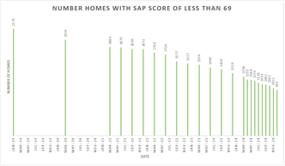

We have delivered the retrofit work via the Social Housing Decarbonisation Fund in compliance with PAS 2035 with the aim of preventing unintended consequences of D&M and we retrofit homes to improve insulation and air tightness. We now have an opportunity to roll some of these lessons and the principes of PAS2035 through our Decent Homes Programme.

As we improve air tightness and insulation in our empty homes, we are currently reviewing specifications to ensure that properties have adequate ventilation in line with PAS 2035 requirements.

We are also exploring the opportunity to deploy smart monitoring equipment either:

- Reactively - install sensors in properties which have experienced D&M, or we believe are at risk of it.
- Proactively - install sensors in large numbers of properties to learn more about what types of properties / areas / archetypes are most at risk of D&M.

We will actively explore access to external funding for these measures.

Objective 5: Effective governance and performance/risk management
The Regulator for Social Housing expects strong Board oversight of stock condition, including D&M, with regular progress reports made to governing bodies. Boards are required to assure themselves that effective processes are in place for customers raising concerns about D&M.

Central to Boards’ seeking assurance is effective performance and risk management frameworks which give the Board a clear view as to the effectiveness of the processes in place for D&M and to ensure the principles within this strategy are effective and on plan.

In line with sector best practice, Broadacres operates a performance framework including Key Performance Indicators (KPIs). To identify risk trends and as an “early warning” in ensuring risks remain within risk appetite a suite of Key Risk Indicators (KRIs) is also in place. Board and Committees each hold a suite of KPIs and KRIs.

Each key operational area e.g. property services and customer experience, housing and support also operate a suite of KRIs to assist in the management of key operational risks.

Regulatory feedback is that the Board has the overarching responsibility for oversight of key risks such as D&M in demonstrating legislative and regulatory compliance. Therefore, in response to the feedback from the 2024 regulatory inspection, clear routes and thresholds for escalation to Board have been established and embedded. All KPIs and KRIs are subject to annual review and are dynamic as new risks are identified.

Specific to D&M, the performance and risk management frameworks include both direct and indirect measures as to the effectiveness of the organisational response. These are:

Board
KPIs:

- Tenancy turnover. (Indirect)
- UK Customer Satisfaction Index (UKCSI) overall score. (Indirect)
- Number of homes below SAP C. (Indirect)

KRIs:

- Number of homes identified with D&M over the previous rolling 12 months as a % of all homes. (Direct)

Group Asset & Development Committee
KPIs:

- Percentage compliance of all homes with Broadacres Decent Homes Standard. (Indirect)
- Removal of hazards, % of emergency and urgent repairs attended to within target. (Direct)
- Investment in existing homes, capitalised component spends net of Social Housing Decarbonisation Fund. (Indirect)
- Maintenance spends per home. (Indirect)

KRIs:

- Number of homes with more than 10 reported repairs on a 12-month rolling basis. (Indirect)
- Number of successful disrepairs claims on a 12-month rolling basis. (Indirect)
- Percentage of repairs completed outside target days. (Indirect)
- Reported repair volumes as a % of the previous year. (Indirect)

Group Customer Experience Committee
KPIs:

- All customer transactions within Rant & Rave. (Indirect)
- Repairs satisfaction. (Indirect)
- Repairs appointments kept. (Indirect)
- Complaints outcome satisfaction. (Indirect)
- Contact centre call abandonment rate as % of all calls. (Indirect)

KRIs:

- Number of complaints raised by customers relating to ease of accessing services. (Indirect)
- Number of complaints relating to contractor performance. (Indirect)

Strategic Review
In line with the organisational approach to strategic review the D&M Strategy will be subject to an annual review by the Board. Material to the next review will be the operation of Awaab’s Law which is currently forecast to be enacted in October 2025. There is also an internal audit regarding the effectiveness to the organisational response to Awaab’s Law, which will include an opinion of the effectiveness of this strategic response to D&M scheduled for quarter 4 2025/2026.

Health inequalities: Cold or damp homes - House of Commons Library
English Housing Survey 2023 to 2024: headline findings on housing quality and energy efficiency - GOV.UK
The Housing Health and Safety Rating System (HHSRS) assesses 29 housing hazards and the effect that each may have on the health and safety of current or future occupants of the property. The hazards include D&M. A HHSRS assessment looks at the likelihood of an accident due to the condition of the property and the likelihood of harm caused over the following 12 months. For example, how likely is a fire to break out, what will happen if one does? The assessment will show whether any serious (category 1) hazards and other less serious (category 2) hazards exist.
Broadacres Housing Association Limited (LH4014) - Regulatory Judgement: 30 October 2024 Updated 30 October 2024 Broadacres Housing Association Limited (LH4014) - Regulatory Judgement: 30 October 2024 - GOV.UK
Source Housemark
Met Office Climate summaries mwr_2023_01_for_print
Trust is the belief that someone or something can be relied on to do what they say they will. Trust is the cornerstone of any social relationship. The “trust equation” is the foundation of the Customer Strategy and underpins the basis of customer relationship at Broadacres. 